**EXPERIMENT # 6**

**Aim: Study and Analyze the Kirchhoff’s Current Law**

**Task:** Calculating current across each resistance using Kirchhoff’s current Law

2. Find total numbers of loops and equations for KCL

Note: design the circuit on electronics workbench and logic trainer with available resistances value.

# Material

* Resistors
* Multi-meter
* Voltage source

# Procedure

1. We took resistors and constructed a series-parallel circuit as shown below.

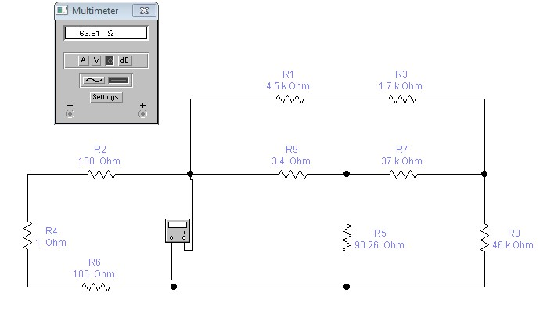

1. Identified points between which current can be measured.
2. In the given drawing, these nodes are A, B, C, D, E and F.
3. The measured currents are indicated as I, I1, I2, I3, I4, I5, I6, I7 and I8.
4. The current between the wires red probe connected to initial point of wire and black probe connected to final point.
5. The currents may also be measured by interchanging the probe position between any two points.
6. Measured and noted all these currents.
7. These are equations for KCL at nodes.

**Node A**

I – I1 – I2 – I3 = 0

**Node B**

I1 – I4 – I5 = 0

**Node C**

I3+ I5 – I6 =0

**Node D**

I4 + I6 – I7 = 0

**Node E**

I2 + I7 – I8 = 0

**Node F (voltage source)**

I8 – I = 0

**Verification**

# Node A

I – I1 – I2 – I3 = 0

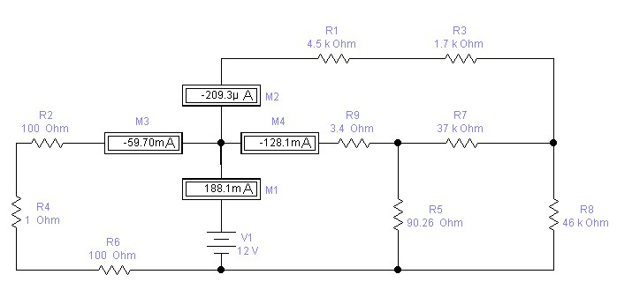

# Node B

I1 – I4 – I5 = 0

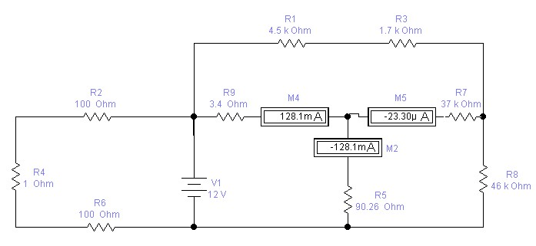

# Node C

I3+ I5 – I6 =0

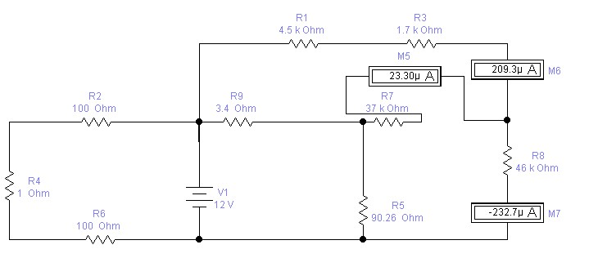

# Node D

I4 + I6 – I7 = 0

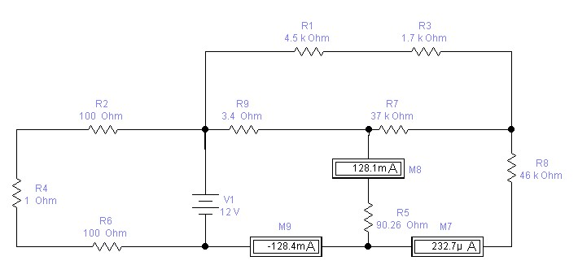

# Node E

I2 + I7 – I8 = 0

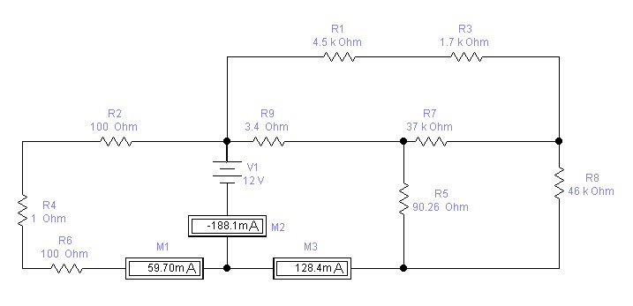

# Node F (voltage source)

I8 – I = 0

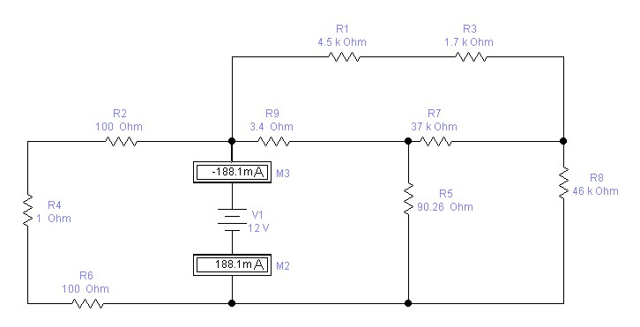

INSTRUCTOR VERIFICATION SHEET

For each verification, be prepared to explain your answer and respond to other related questions that the lab TA’s or Instructors might ask.

Name: Date of Lab:

Q. No. 01

Q. No. 02

## Q. No. 03

Verified: Date/Time: